Christmas 2008
Well 2008 has been quite a year for the Philson family. When we left off in 2007, we had just had an Ice Storm from all that Global Warming we've been hearing about, but due to our Flame-O Transformer, we were able to warm up our home and most of the neighborhood.
January wasn't much warmer and with the cost to heat our house going up, we cut back on the thermostat like many of you have, but we still had Flame-O to keep us warm. We were getting along fine until the neighbors reported us to the Green Police. They burst into our house with such a fury that our dog Peaty peed on the floor! They shouted at us to turn Flame-O off and that something about Flame-O's carbon footprint being Un-American. I was still in a daze. One of them said something about "Going Green" and then I came to and said I was "Going Ballistic" then put my carbon footprint up side his head, Billy Jack-style. (You see I wear Dr. Scholl's Odor Eaters that have a carbon insert.) Meanwhile, in all the commotion, Flame-O slid in Peaty's pee and shot his flame through the ceiling catching our house on fire!

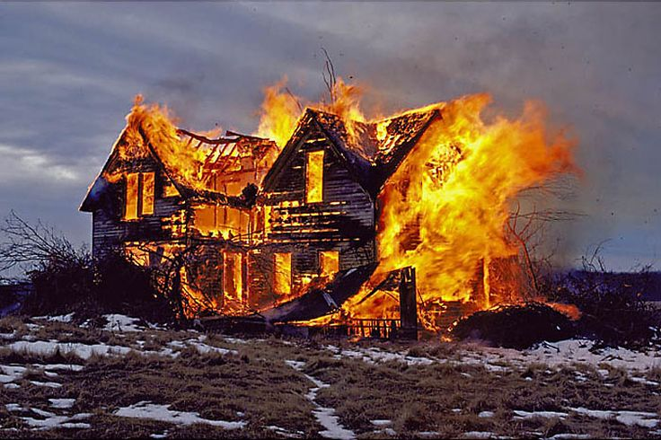
Thankfully we all got out alive, but the damage done to our house was a tragedy. Regardless of who was right or wrong, Flame-O was taken away. We will miss Flame-O, but we heard he found a home in California of all places.
We were homeless but on a good note, we had purchased the house with a Fannie Mae loan with no money down, had inflated the value of the property 125% and had never paid any of our house payments. We had taken out a Home Equity loan on the inflated value of the house...well let me just say we were homeless but we had some money in the bank...who could that hurt? We took some money and invested in a Winnebago (The Behemoth) that got 5 MPG Highway and 1 MPG City. What a deal...I thought...When the price of gas was at $4.00 a gallon, we had to find a RV park near a gas station to not run out of gas during short trips to the grocery store. We went through our savings in a heartbeat. We needed jobs.
In early November 2007, Georgia & I had sent out some feelers regarding assisting in the campaigns for the White House. Our resumes were sent to most of the candidates on either side of the aisle. Having had a real feel for these types of elections, we were soon being courted by several candidates. In 2004, Georgia had work on the Kerry-Edwards ticket and so John Edwards was the first to knock on our Winnebago door. He hadn't changed a bit. He looked Georgia over like she was a piece of candy and started using his Southern charms on her. Georgia had heard enough of that four years ago and reminded John of the information we had on a "love child" he had with a campaign worker. He laughed, let the air out of one of our tires and said that was not true and that he had not had sexual relations with that woman...How Presidential! He left in a hurry and I called my son, Daniel who was working for the National Enquirer. My son got a promotion and we had one less job opportunity.

Barack Obama had talk with Georgia and me around Christmas time last year and he was behind Hillary Clinton at the time. He knew we had knowledge on the Clintons like nobody else as we had served in the administration and were close to them. As Hillary was distancing herself from all of her husband's acquaintances, Georgia and I had not been approach by the Clinton Camp although Bill Clinton had approached Georgia on several occasions. After some salary negotiations, Georgia was on the O-Force One and on point to get Barack the Democratic nomination... her first move was a key one in the Iowa Caucus. Georgia saw to it that livestock were allowed to vote in the Democratic primary for the first time thanks to her friends at ACORN. Needless to say, this was a tipping point in the campaign with Obama narrowly beating out Edwards and Clinton.
While Georgia was on another campaign, I took time to visit an old friend in Las Vegas. O.J. Simpson and I hadn't been able to get together for some time. We were on the outs with the Juice as Georgia had testified against him in 1994, but then became a juror in 1995 and set him free. In a spirit of friendship and teamwork, O.J. and I got together in Vegas and revisited the trial transcripts, watched old Court TV episodes of the event and even watched the entire Naked Gun trilogy in an effort to see if we could find the "real killer". Although it was fun watching his expressions in the old trial footage, he expressed regret on never finding his "One Armed Man" as Richard Kimball did in The Fugitive.

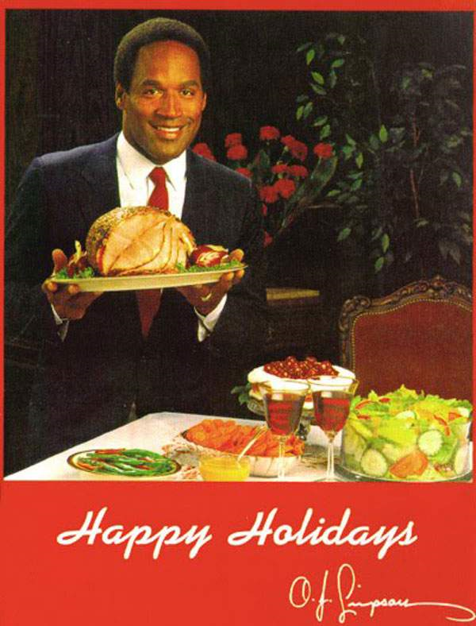
The Juice had allot on his mind as in late 2007, he had been arrested for alleged robbery and kidnapping. He convinced me of his innocence, but he still seemed down. To cheer him up, I called retired Judge Lance Ito and we all met at the Palace Casino for a little fun. “The Itonator”, was his usual self with a woman in both arms and wearing plenty of "bling". We got to talking about Simpson's legal problems and how they had distracted him from finding Nicole and Ron Goldman's killer. Then it hit me...use O.J.'s legal problems to his benefit. He was so clearly innocent, (I mean celebrities never do illegal things) that he was bound to be found innocent according to The Judge and his fine lady friends.

We developed a scheme to build a stronger case against O.J. and The Juice came up with some real good facts that could be used against him, if true. When he was found guilty, he could make connections in prison, devote more time to his search and be away from the tabloids. To cinch the deal, Lance pulled some strings and got me on the jury. All the hard work paid off and we cheered secretly when O.J. received between 9-33 years in prison! With that kind of time, he surely will find the killer who we agree is in prison or at least on his way. He sent me out this Christmas card. He knows how to carve a ham!

Georgia and I were busy in 2008, but the kids were doing well on their own. As I mentioned earlier, Daniel had a job with the National Enquirer and did a great job. He caught the attention of Lehman Brothers. Daniel quickly rose in the organization with his investment strategy (which he learned from his dear old dad) and was on top of the world. Subprime mortgages didn't work out as well as I anticipated and Daniel lost his job when Lehman Brothers filed for bankruptcy. I knew Daniel would do something historic and the largest bankruptcy in history is still something.
Maggie and Whitney both got married...and get this...to the SAME guy! They were both living down about 45 miles southwest of San Angelo, Texas on the YFZ Ranch, also known as the Yearning for Zion Ranch. This was a polygamist sect's compound that had the girls socializing with as many as 700 others with many being children. They had pillow fights and taffy pulls...it was like camp! We never met our son-in-law, Jebadia, because by the time we were ready to make a trip down the Texas law enforcement did a raid on the facility and placed everyone under custody for God knows what. With my run in with law enforcement, I imagine it was uncalled for and petty. Maggie and Whitney were fortunate to be at the San Angelo Sam's Club doing some shopping for S'mores for a party of 400. They made their way back home to Oklahoma with a pick-up full of graham crackers, Hershey bars and marshmallows. Husbands may come and go, but that amount of s'mores will last a lifetime.
Georgia ran another successful campaign and President-elect Obama has promised significant staff or Cabinet positions in his administration to both Georgia and I. As he is hiring allot of old Clinton staffers, Georgia & I expect to hear back soon. In these hard financial times, it will be nice to be in a secure, high paying, low accountability government job again. Thank God the price of gas has fallen. Our Winnebago is back on the road again and headed for the Washington, DC area. With the family all together again, we see each day as a blessing and hope God is blessing you and your family as well as ours.

Merry Christmas
from
The Philsons

